# User Interactions:

## User screen:

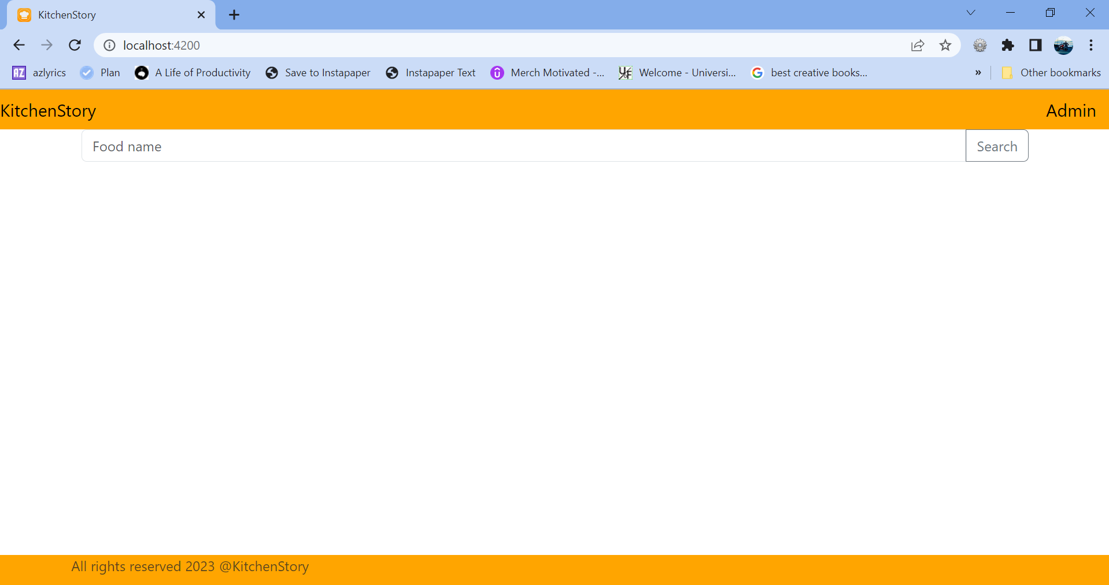

## User searches “Idli” food item:

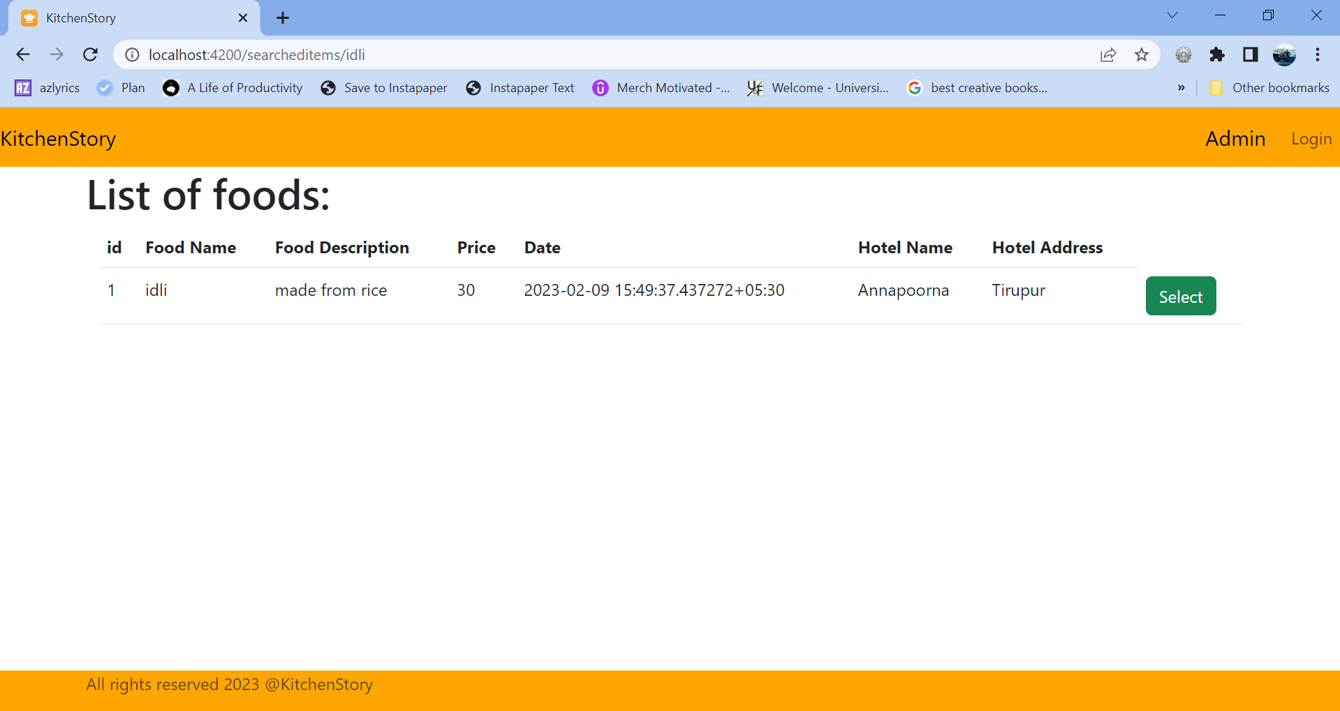

## User selects the id 1: which goes into the overview page:

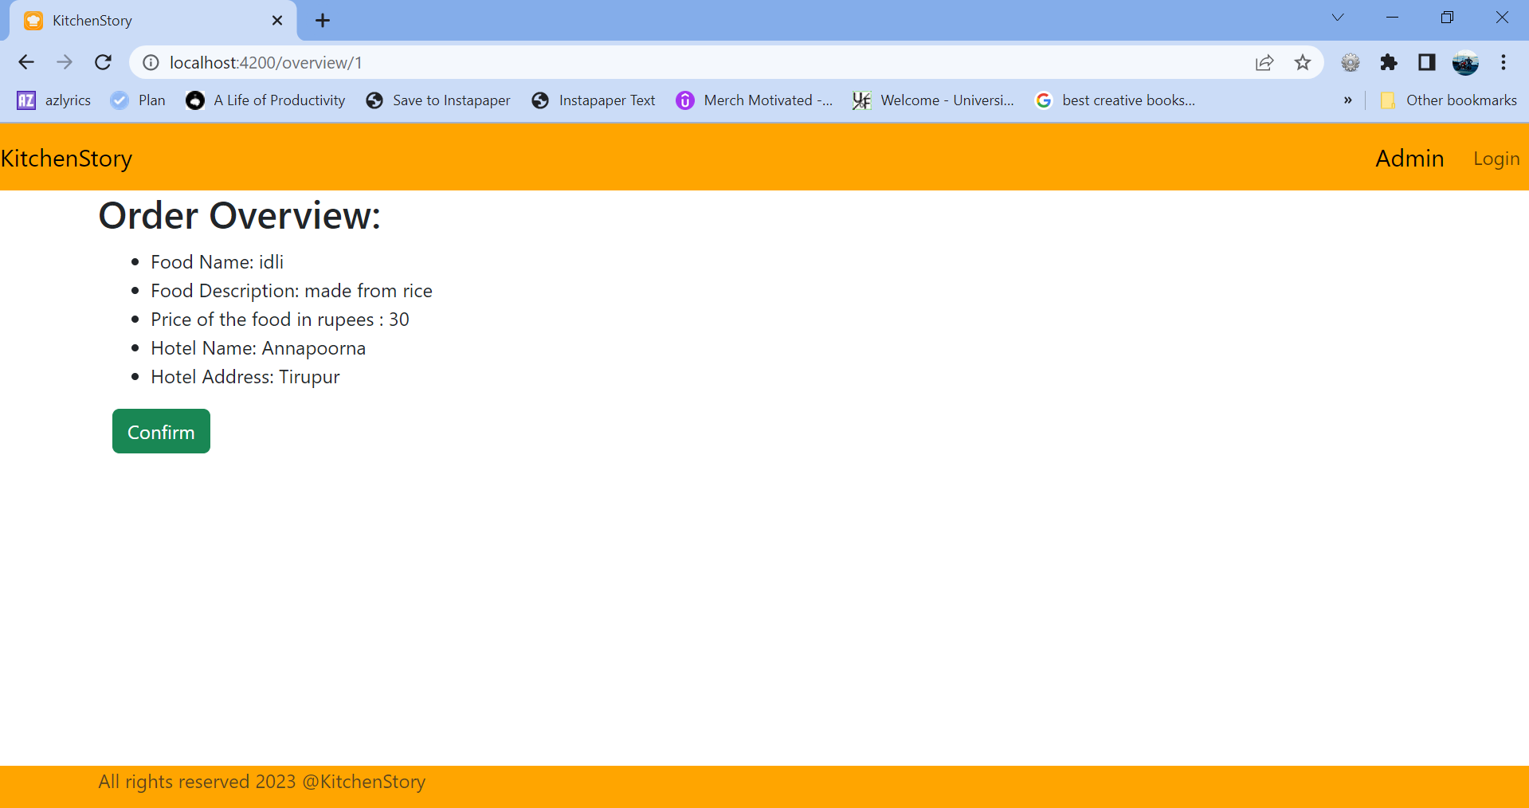

## When User clicks confirm button: Goes to checkout page: Now User can click Home to go back to the localhost:4200/

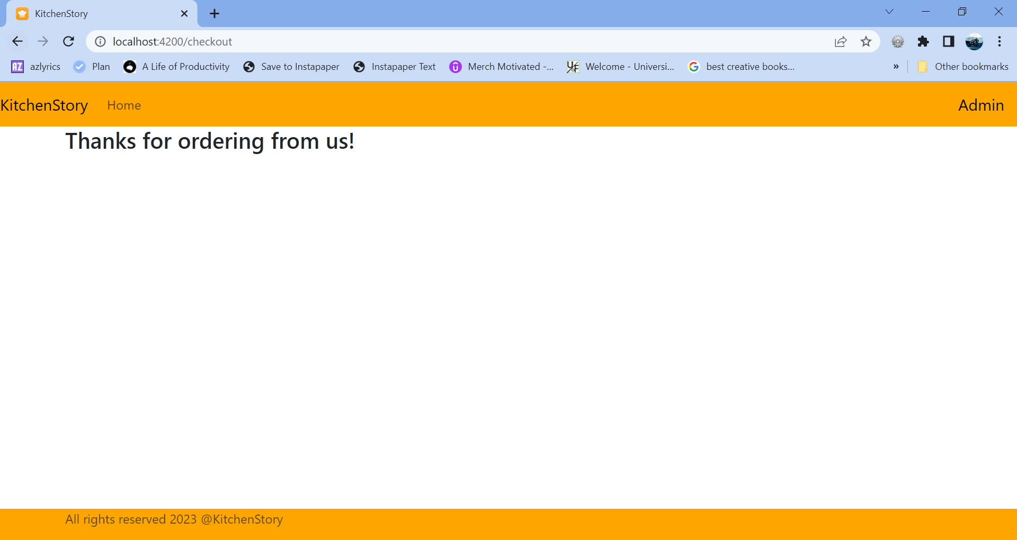

# Admin interactions:

## Admin Login page: Admin can click Admin tab on the right side of the nav bar. Or use URL - /admin

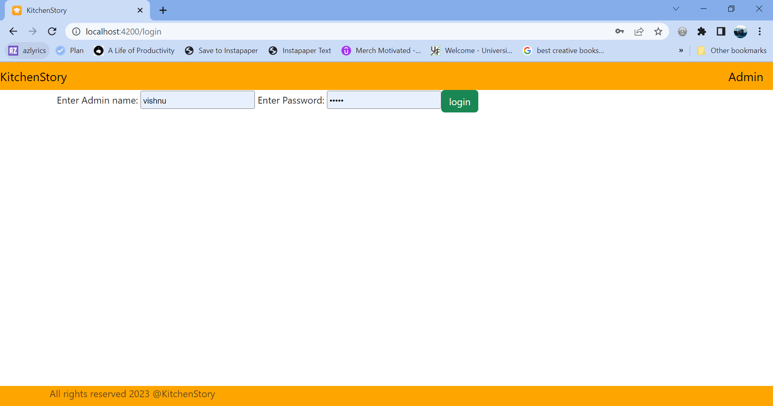

## User validation:

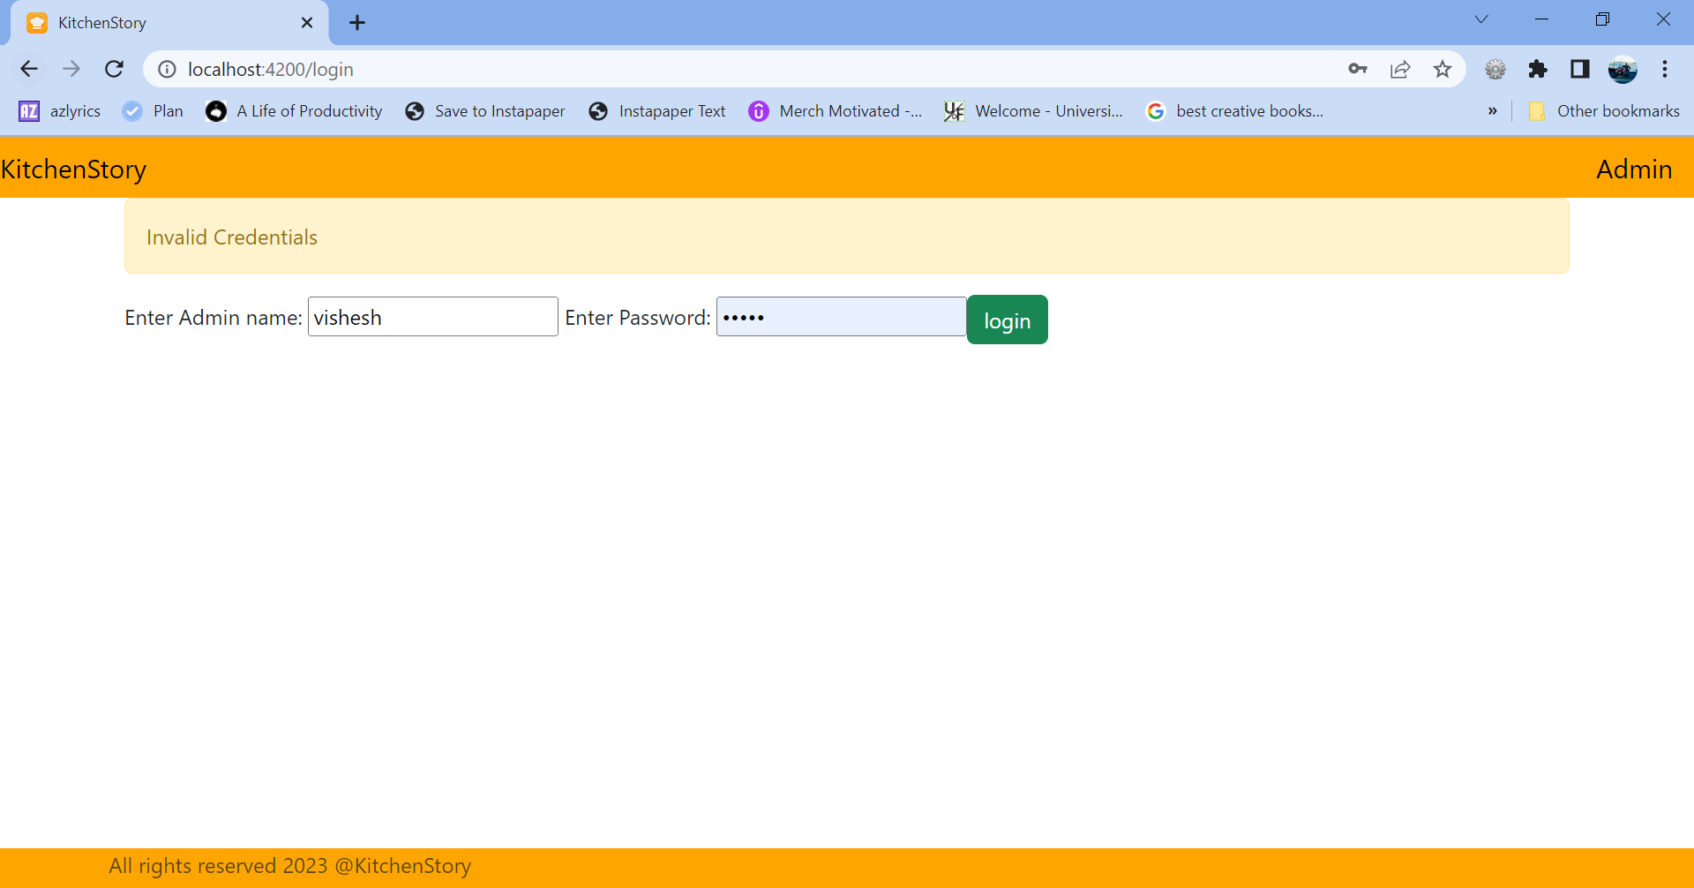

## Once User enters the home screen,

1. Ability to add a food item directly in the home page
2. Admin can click All Foods tab on the nav-bar to go to inventory page

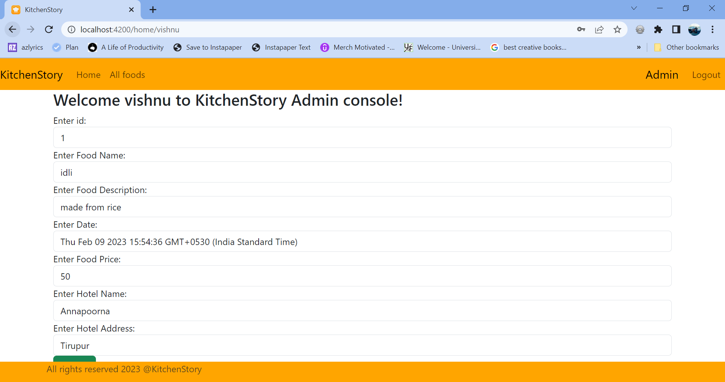

## Inventory page:

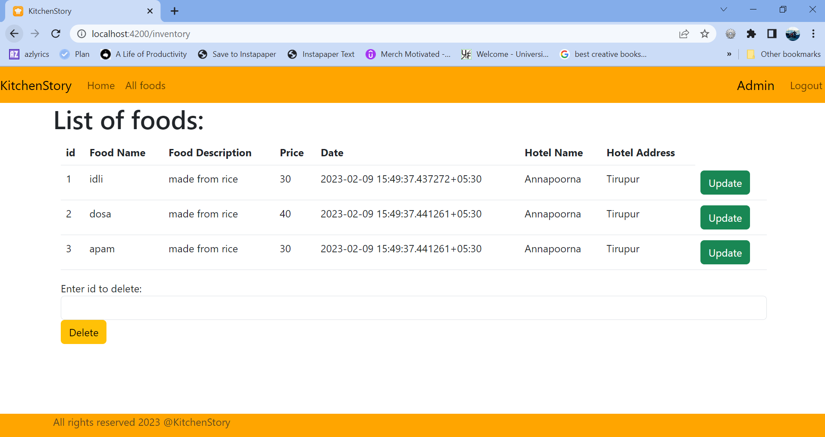

## Adding an item from home page:

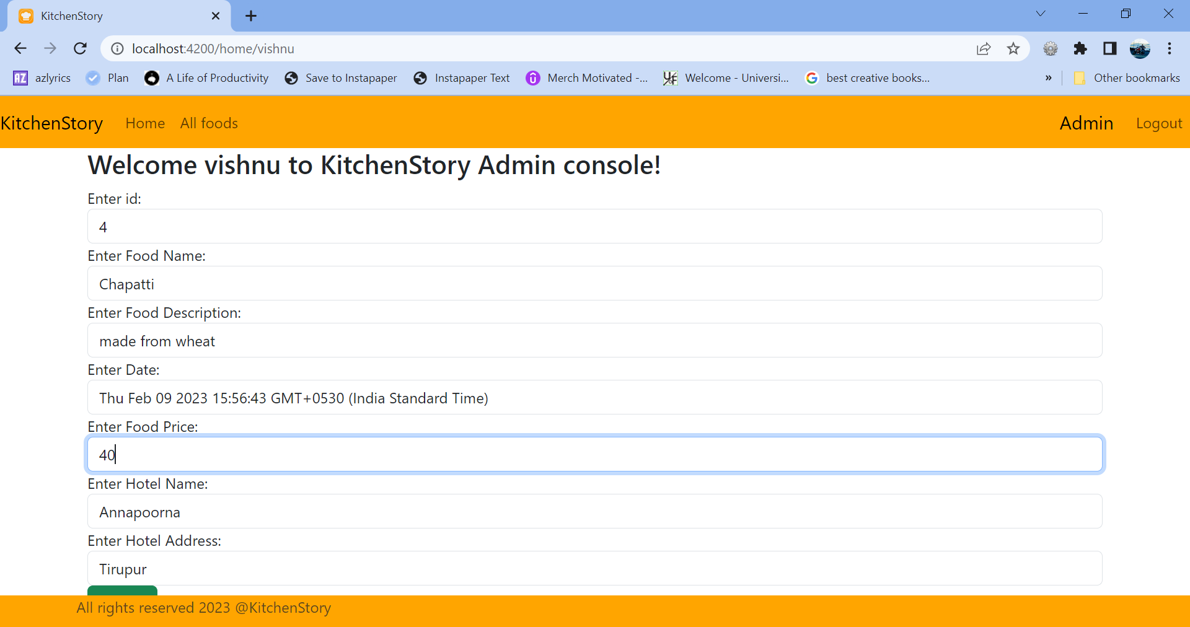

## 4th item is added in the table(database),

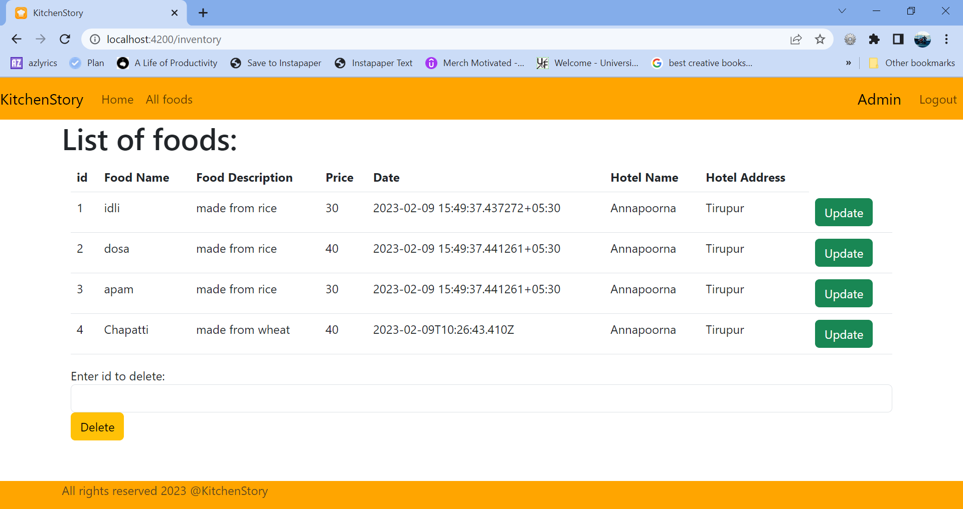

## Deleting an item:

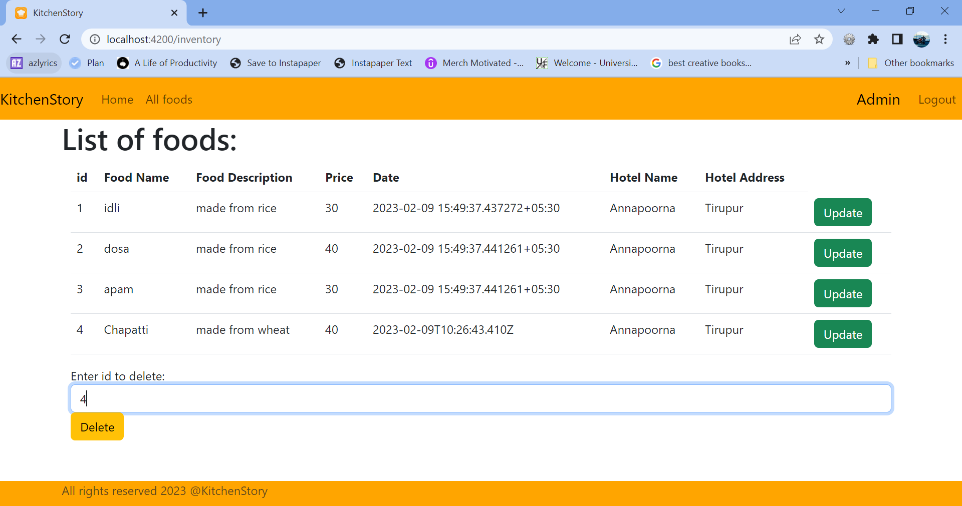

## After deletion,

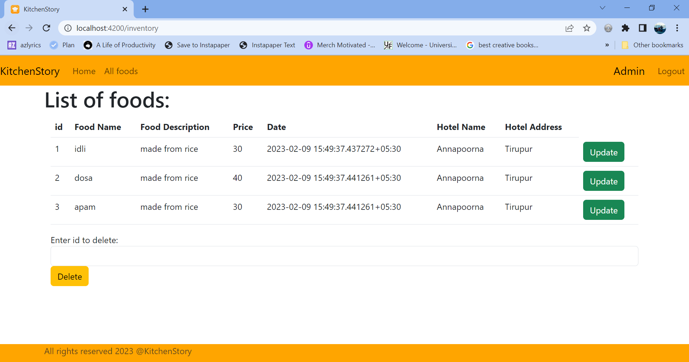

## Updating an item using the Update button on the left side of an item, it navigates to update inventory/{id} page,

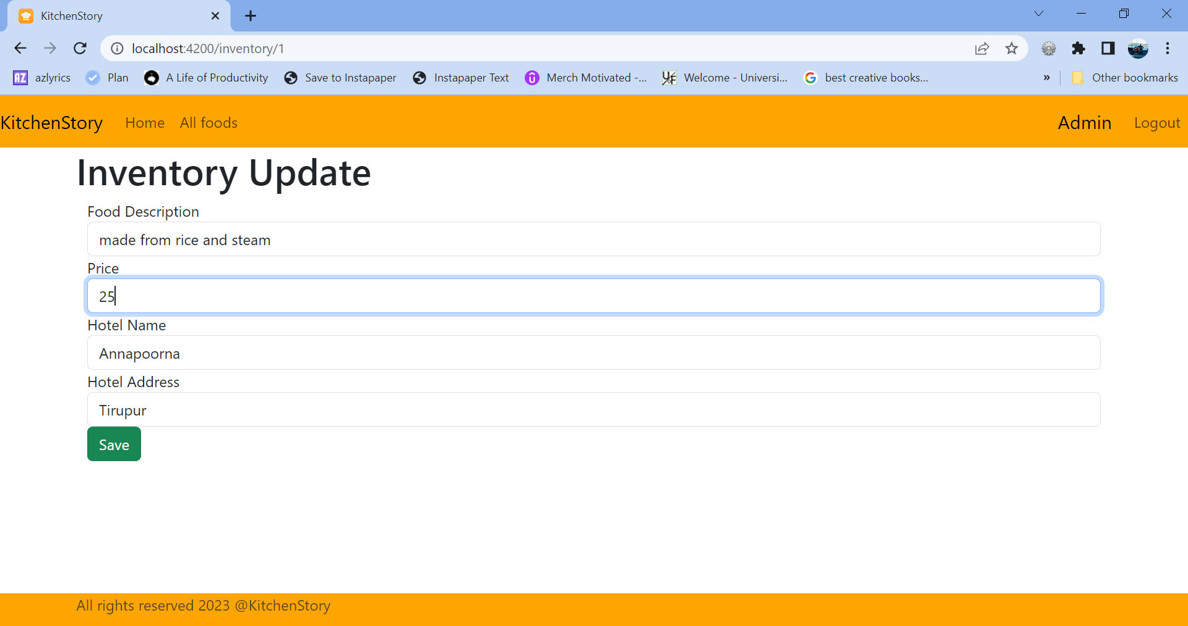

## After update,

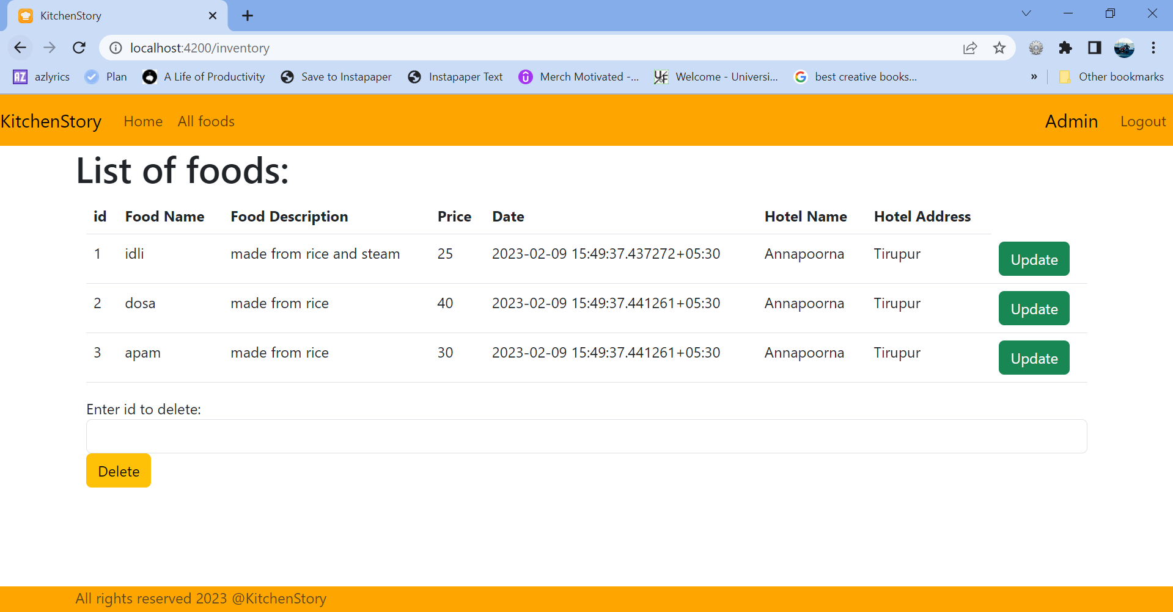

## Logout of Admin,

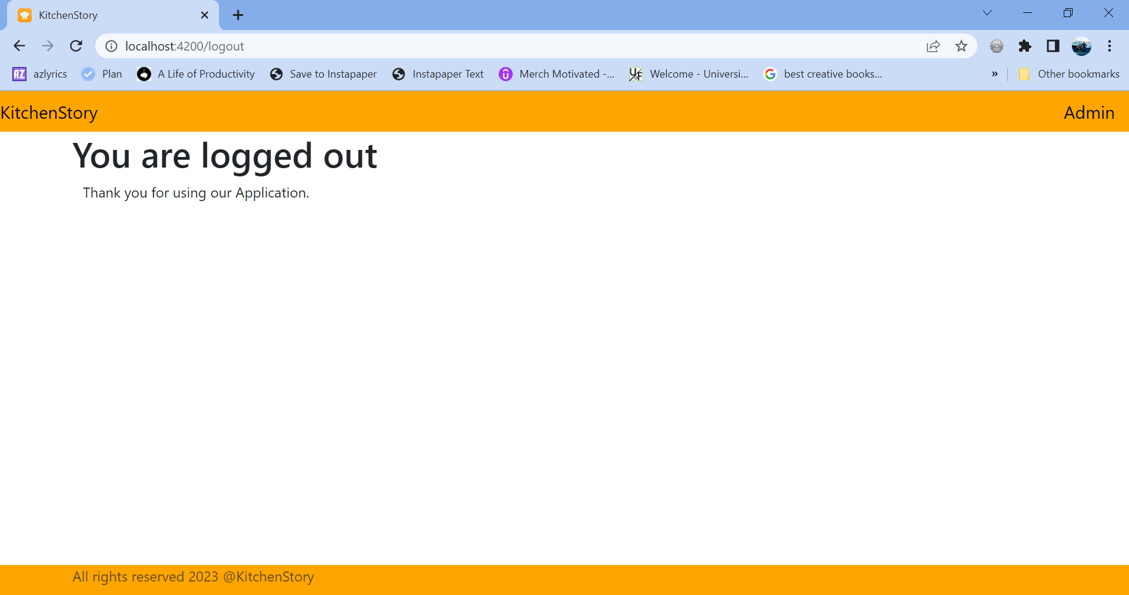

Admin is logged out, he/she can use the Admin tab to re-enter credentials to enter into the application.